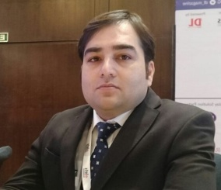**JECRC**

**A**ffix and Attest

passport

size photograph

**JAIPUR**

**INDIVIDUAL FACULTY DATA SHEET**

|  |  |  |
| --- | --- | --- |
| **Name of the faculty member** | **:** | Sidharth Chaturvedy |
| **Present Designation** | **:** | Head Outreach & Incubation , Asst.Prof. (ECE) |

**Email Id:** [**sidharth.ece@jecrc.ac.in**](mailto:sidharth.ece@jecrc.ac.in) **; outreachcell@jecrc.ac.in**

**Contact Details: +91-7742794901**

**I. Particulars of Educational Qualification: (*only completed*)**

|  |  |  |  |  |  |
| --- | --- | --- | --- | --- | --- |
| **Category** | **Name of the Degree** | **Specialization** | **Year of Passing** | **Name of the College** | **Name of the University** |
| **UG** | **B.Tech** | **E&TC** | **2003** | **Raipur Engineering College** | **P.R.S.S.U** |
| **PG** | **Master of Science(M.S)** | **Advanced Embedded System Design** | **2009** | **International Institute of Information Technology** | **P.U.** |
| **Ph.D.** |  |  |  |  |  |

**II. Academic Experience : 5 Years**

**III. Industrial Experience : 10 Years**

**IV. Title of Ph.D. Thesis : NA**

**V. Awards/Achievements : NA**

**VI. Research/Specialization : NA**

**VII. Course Taught : DSP,Embedded Systems,DE,EDC,SS,CS,DIP,VHDL,CA**

**VIII. Refereed International Journal Publication : NA**

**IX. International Conference Proceeding :NA**

**X. Books Written : NA**

**XI. M.Tech Thesis Guide : NA**

**XII. PHD Thesis Guide : NA**

**XIII. Professional Body Membership : NA**